TASK 1
1st command: az vm list
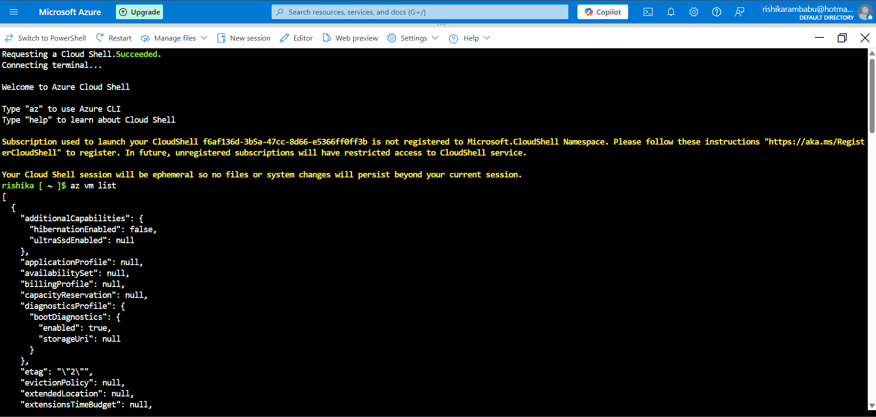
2nd command: IPADDRESS="$(az vm list-ip-addresses --resource-group "RishikaKriti-VM_group" --name KritiRishika-VM --query "[].virtualMachine.network.publicIpAddresses[*].ipAddress" –output tsv)"
3RD command: curl –connect-timeout 5 http://$IPADDRESS
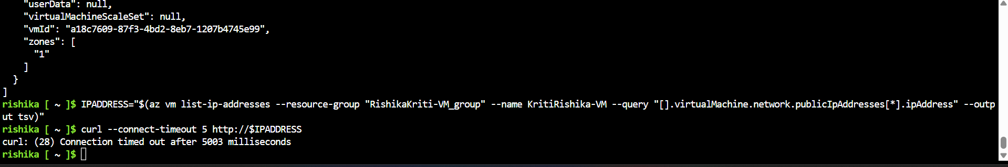
Curl: (28) connection timed out after 5003 milliseconds
4th command: echo $IPADDRESS
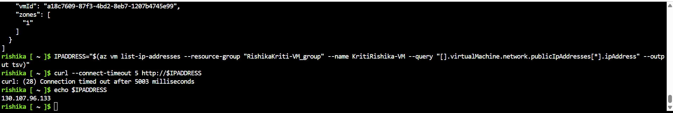
OUTPUT: 130.107.96.133

In the web browser type the public ip which we got from azure vm
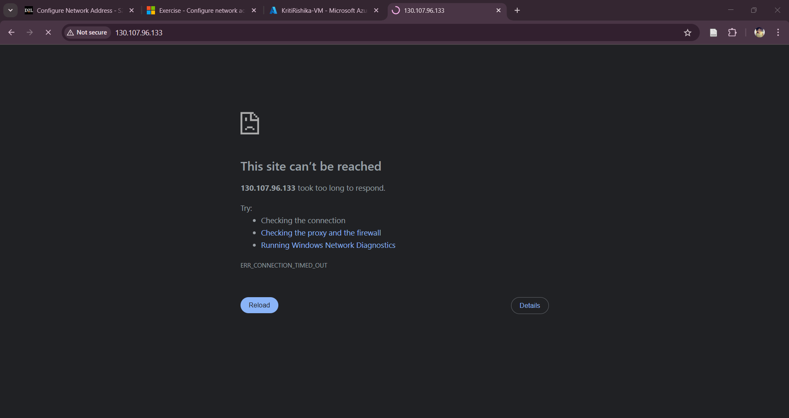
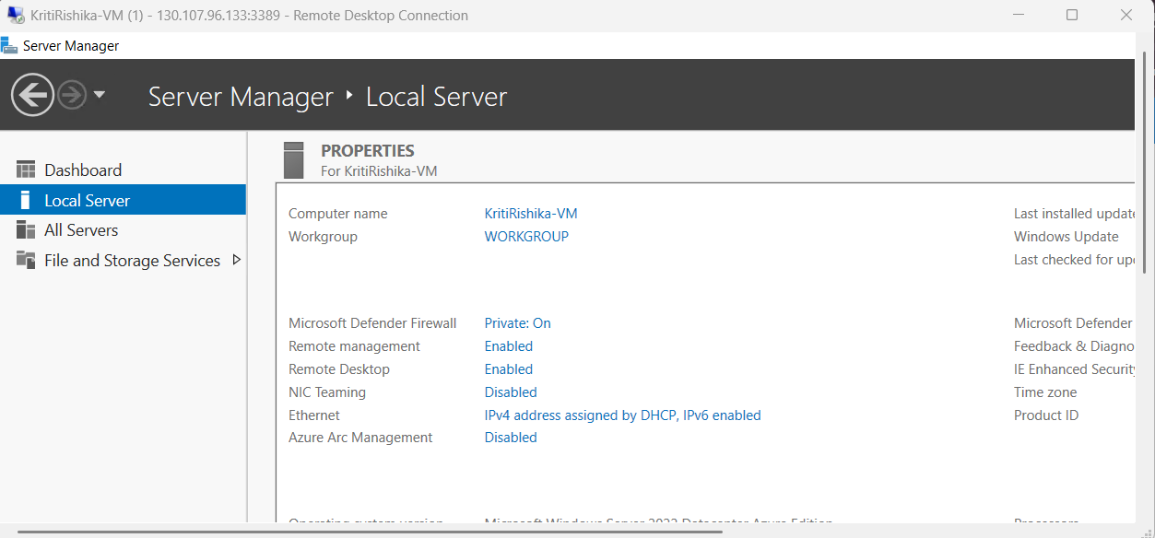
TASK 2
1st command: az network nsg list
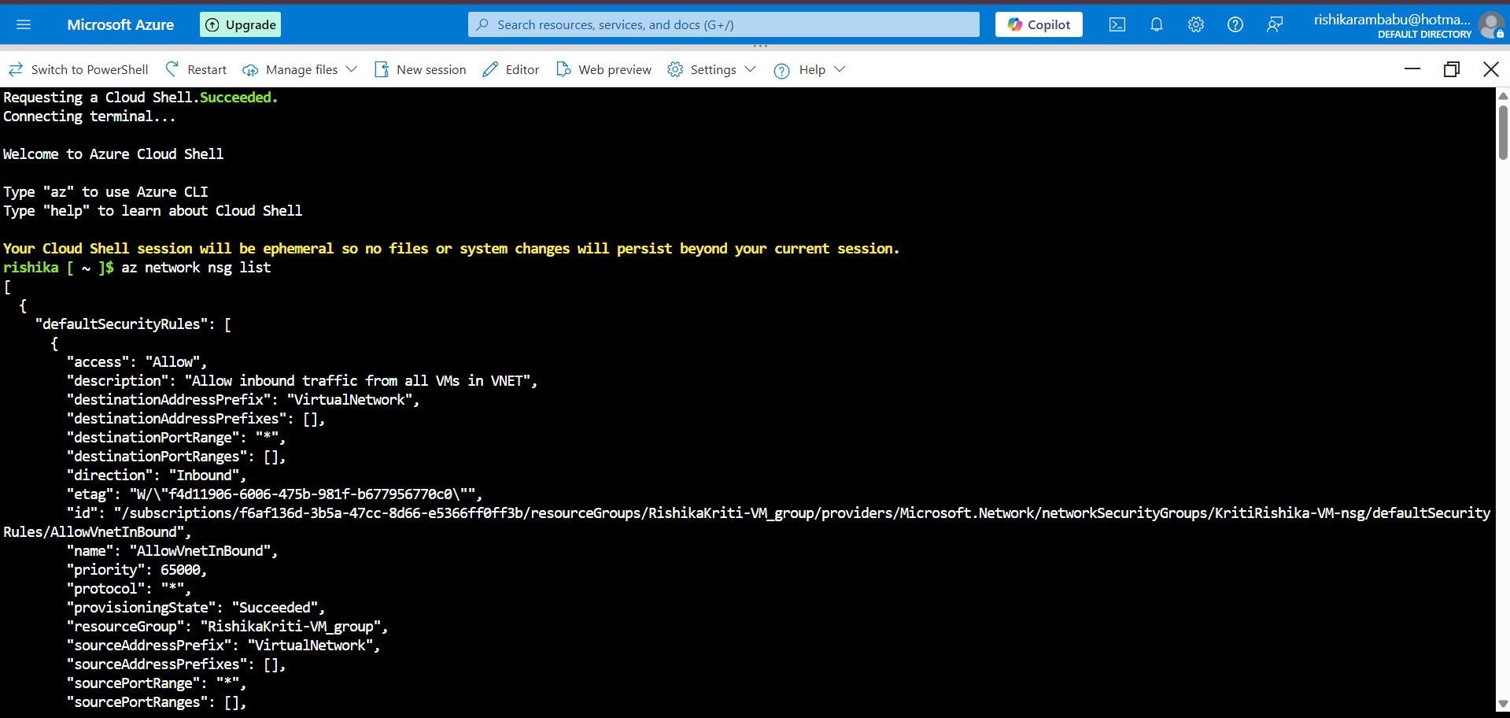
2nd command: az network nsg list –resource-group “RishikaKriti-VM_group” –query ‘[].name’ –output tsv
Output: KritiRishika-VM-nsg
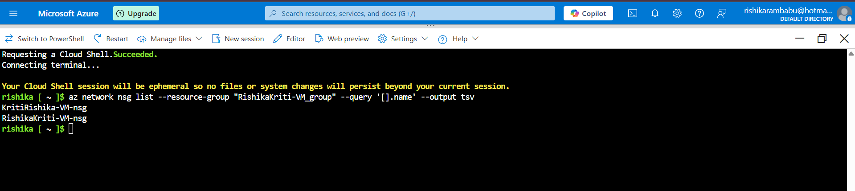
3rd command: az network nsg list --resource-group “RishikaKriti-VM_group” –nsg-name KritiRishika-VM-nsg
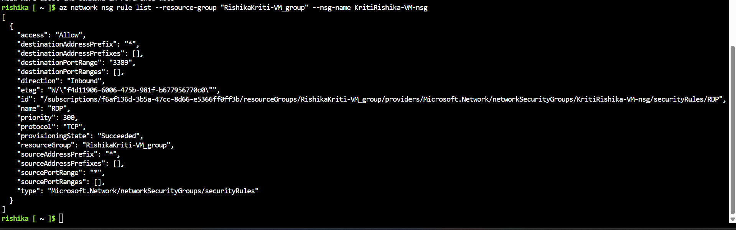
4th command: az network nsg list --resource-group “RishikaKriti-VM_group” –nsg-name KritiRishika-VM-nsg –query ‘[].{Name:name, Priority:priority, Port:destinationPortRange, Access:access}’ –output table
5th command: az network nsg rule create –resource-group “RishikaKriti-VM_group” –nsg-name KritiRishika-VM-nsg –name allow-http –protocol tcp –priority 100 –destination-port-range 80 –access Allow
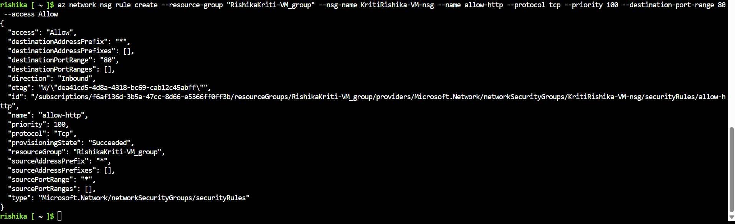
6th command: az network nsg list --resource-group “RishikaKriti-VM_group” –nsg-name KritiRishika-VM-nsg –query ‘[].{Name:name, Priority:priority, Port:destinationPortRange, Access:access}’ –output table

